Robot Framework – Jenkins Integration

Table of Contents
1 Pre-install 3
2 Jenkins Installation 4
3 Robot Framework Plug-In for Jenkins 4
4 Scheduling the batch file using Jenkins 4
5 Post-build Actions Configuration: 5
6 Change history 6

Pre-install

System Requirements
Minimum Recommended Configuration:
- Java 8 (either JRE or JDK)
- 256MB free memory
- 1GB+ free disk space

Stand-alone or Servlet
Jenkins can run stand-alone in its own process using its own built-in web server (Jetty). It can also run as one servlet in an existing framework, such as Tomcat or Glassfish application servers. This section is specifically targeted to stand-alone install and execution on windows.

Jenkins Installation
Below are the steps to install Jenkins:

Download Jenkins.zip from Jenkins home page (https://jenkins.io/download/)

Unzip above file and run the installer jenkins.exe

The Jenkins localhost page will open. Follow the instruction to login to your Jenkins

This installer, installs Jenkins as Windows service. This can be verified by checking if the Jenkins service is up and running in Services.exe

Once the installation is complete, deploy the war file using command line:

java -jar jenkins.war

If it gives a severe error, “Address is already in use”, it means that the port:8080 is in already use by other application. Use below command to change the port for Jenkins:

java -jar jenkins.war --httpPort=9090

Once this process is complete, your Jenkins is ready to use.

Robot Framework Plug-In for Jenkins
Using the Robot Framework Plug-In for Jenkins is really a nice enhancement to present the Robot Framework results. Installing the Plug-In is a no-brainer from the build-in Jenkins Plug-In page:
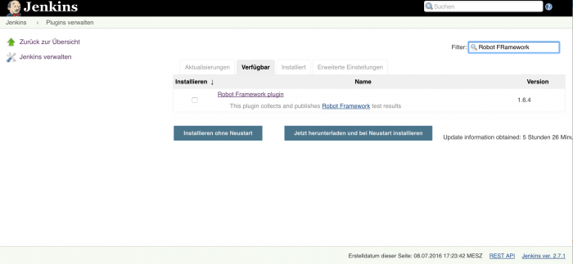
Once the Plug-In is installed we only have to do minor modifications to our existing job to take it into use. First of all we are again storing the Robot Framework results to some folder in our Jenkins workspace. To not break our integration with the Apache installation we are copying the files still to the corresponding http-directory in addition.

Scheduling the batch file using Jenkins
Robot framework batch file can be scheduled depending on Jenkins builds as below:

Go to the required project in Jenkins

Click on Configure

In Build Trigger section make the changes as shown below:

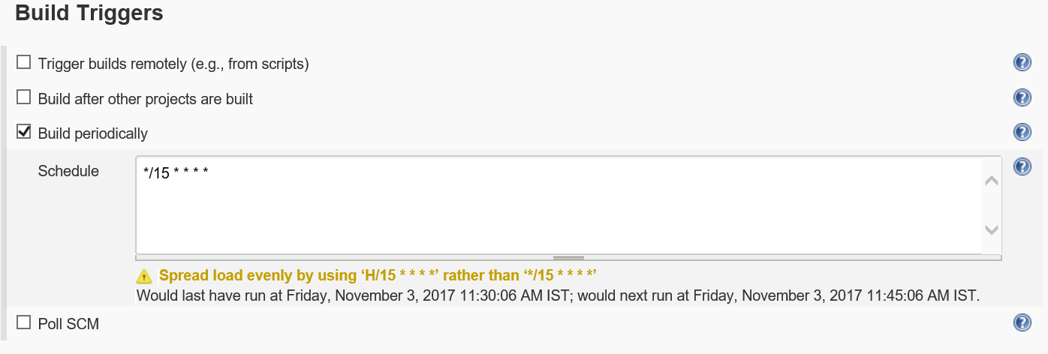
The Schedule field value can be customized as per requirement.

In the Build section, add a call to batch file as shown below:

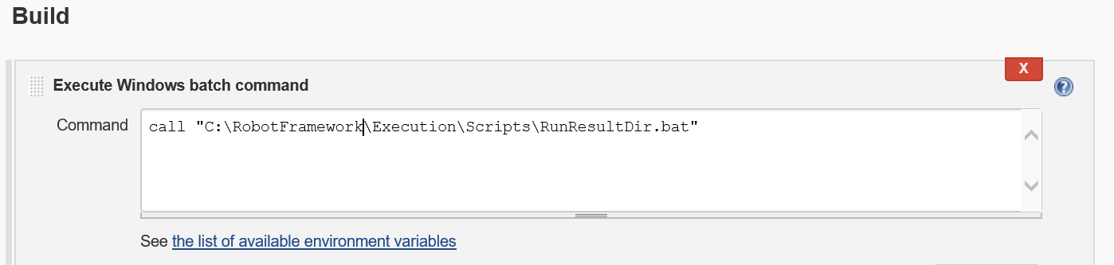

Click ‘Apply’. Now your execution is scheduled. The mentioned batch file will be triggered at the time specified in the Build Trigger section.
- You might have direct pybot/jybot command here like "pybot --variable name:value --outputdir my_robot_results my_test_suite" or in case you need to do something more, you can call any script that you use for running the tests. Relevant part from Robot Jenkins Plugin point of view is that this script generates the Robot outputs.

Post-build Actions Configuration
- Select: Post-build Actions -> Publish Robot Framework test results
- Set path where your results are located (in above example command "my_robot_results")
- If your output files are named differently than default (i.e. output.xml, report.html and log.html) specify the filenames by pressing the "Advanced..." button and writing the names in relevant fields. The fields support wildcards * and ?.
- If you have other artifacts such as screenshots that you want to persist for viewing later in the logs you must configure them under "Advanced... -> Other files to copy". The field accepts comma separated list of files and supports wildcards * and ?.

Note: The plug-in installation was not possible due to a known issue with Jenkins. Hence, the Post-build Actions Configuration had not been tested with this version of Unified Robot Framework.

Change history

Version | Date | Author | Reviewed by | Approved by | Change history
V1.0 | 03-11-2017 | Priti Gaikwad |  |  | Created the document

